**New Code Review SOP**

**The following items must be completed before requesting a code review.**

1. Changes have been made to the Mapping in Altova
2. The mapping has been saved and the code has been generated for the mapping
3. The changes have been tested in a Test Environment
4. Any changes to the mapping console have been converted back to a Production Database

**Requesting a Code Review**

1. To request a code review, navigate to the Pending Changes section of the Team Explorer in Visual Studio.

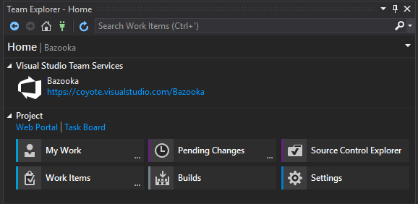

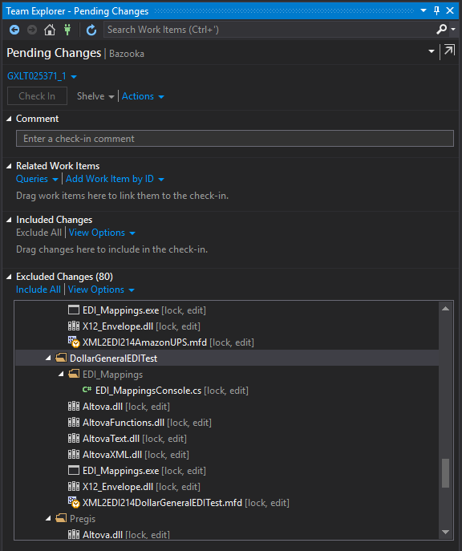

1. **Select the Item you want to submit for code review.**
   1. If the mapping you wish to submit for code review is in the **Excluded Changes** section:
      1. Navigate to Excluded Changes and right click on the mapping’s folder
      2. Select Include

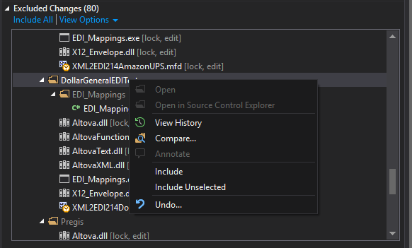

* + 1. The folder and associated dll’s will now be in the **Included Changes** section
  1. If the Included Changes section contains more than one mapping for code review, but you only want to request one mapping:
     1. Navigate to the included Included Changes section and right click on the mapping’s folder
     2. Select Exclude Unselected

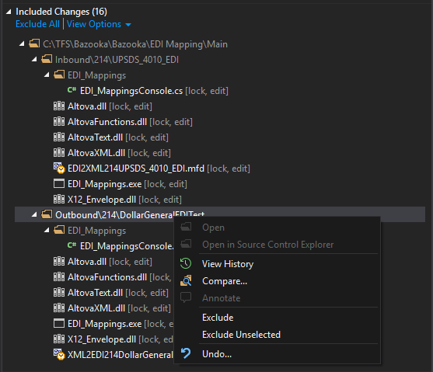

1. **Submit a mapping for code review**
   1. Now that your mapping is isolated, select Actions.
   2. From the drop-down select Request Review

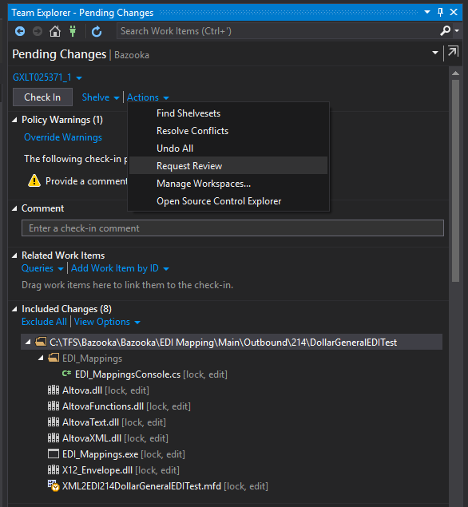

* 1. This will bring you to a New Code Review Window. From this window, you will need to populate the following:
     1. During Peak you will request the code reviewers to be Scott Kemp and Your Manager
        1. The expectations will be that managers will review their teams’ code reviews
        2. If your manager is unavailable, then it is expected you will find one of the other managers to review your CR.
     2. 5 Code Reviewers: Scott Kemp, Scott Quest, Kate Schreiber, Lindsey Garety, Jamie Rama
     3. Subject of the code Review (Must include INC or PRJ #)
     4. Bazooka\EDI tag
     5. Detail description of what was changed
  2. Once these fields are populated, select Submit Request

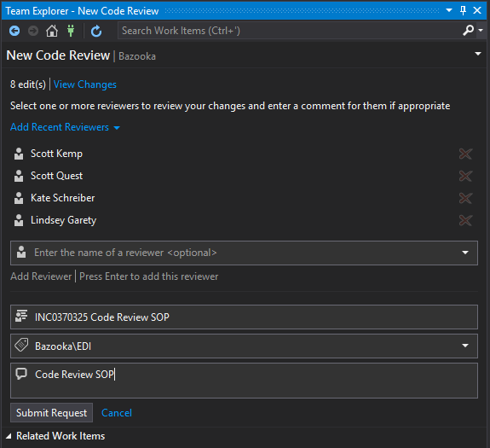

**Actions to be Performed by Reviewers**

1. **Accepting/Declining a code review** 
   1. To Accept or Decline a code review, navigate to the My Work section of the Team Explorer in Visual Studio.

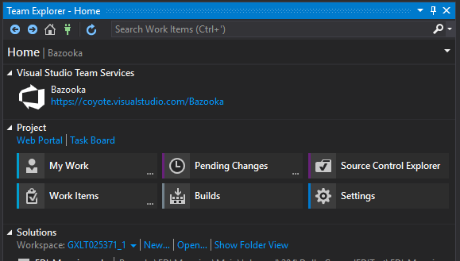

* 1. Navigate to the My Code Reviews & Requests section beneath Code Reviews and double click on the request code review

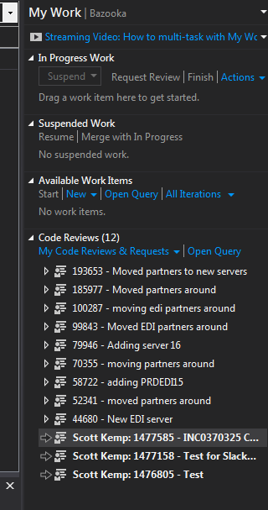

* 1. Beneath View Shelveset, you will have the option to Accept or Decline a code Review.
  2. Select Accept or Decline

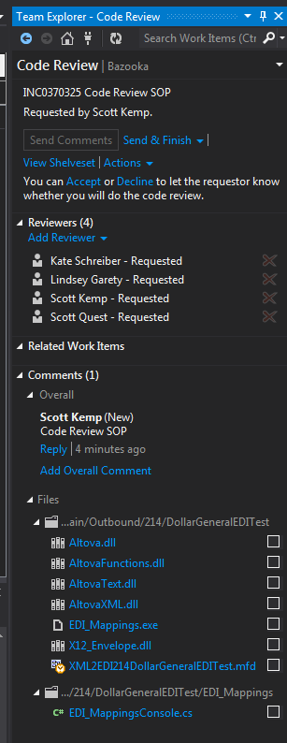

* 1. When you Accept or Decline the Code Review, this will send an email to the Code Reviewer with your selection.
  2. This does not indicate that the code has been reviewed and completed. This indicates that a reviewer intends or does not intend to review the code review being requested.

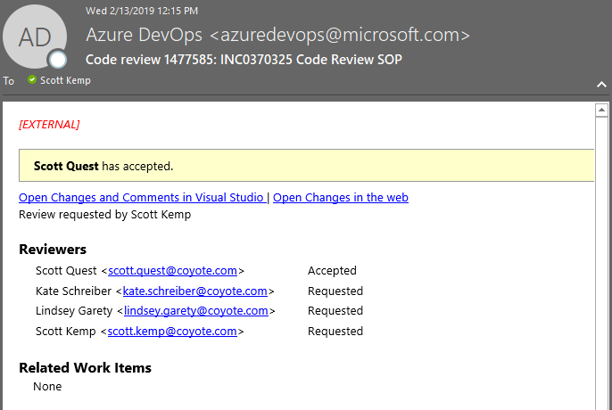

1. **Performing a Code Review**
   1. From the code review email select Open Changes in the web



* 1. This will open a new tab in your browser.
  2. From the browser, right click on the mfd file and select download.

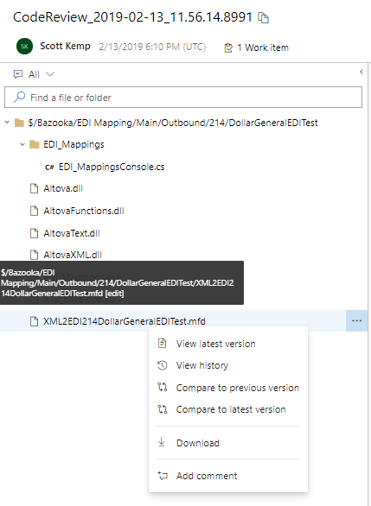

* 1. This will prompt a downloadable file for you to open or will directly open in Altova

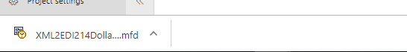

1. Open the file in Altova. The file you’ve opened will include the changes made by the Requestor
2. Review the mapping in Altova
3. Review the Tests done to perform testing in the EDITest Environment
4. If a mapping console was updated to perform testing. Check the mapping console checked in to make sure it has been updated to prod.
   1. This can be reviewed by Navigating to the EDI_Mappings folder of the mapping.
   2. Right click on the EDI_MappingsConsole.cs file and select View

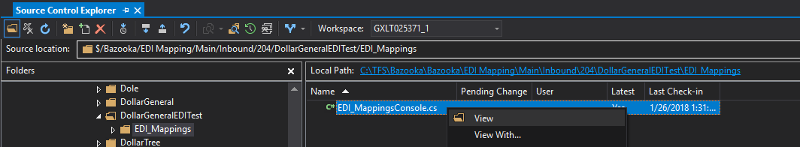

1. This will open the EDI_MappingsConsole.cs file in a new tab within Visual Studio to review.

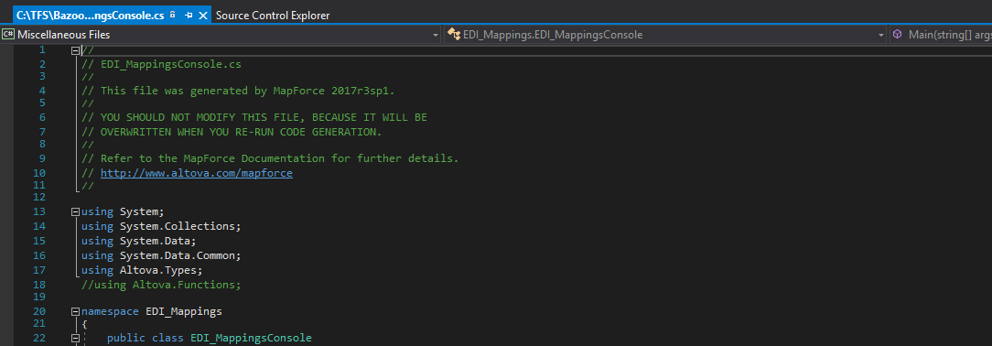

1. Once you have successfully reviewed the code, you will have three options to submit back to the Requestor:
   1. Looks Good
      1. Indicates the changes can be deployed to production.
   2. With Comments
      1. Indicates the comments need to be addressed and a new code review must be submitted with corrections
   3. Needs Work
      1. Indicates the changes made are insufficient and a new code review must be submitted with corrections
2. To Send and Finish with one of the three options
   1. Navigate back to the code review
   2. Select Send & Finish
      1. Select Looks Good, With Comments, or Needs Work from the drop down

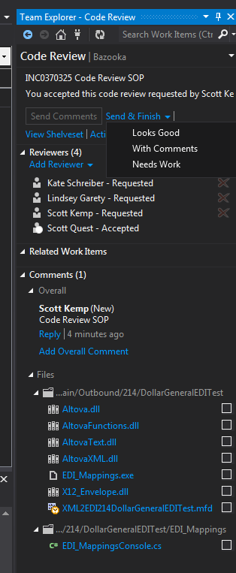

* + 1. When you Finish the review, this will send an email to the requestor

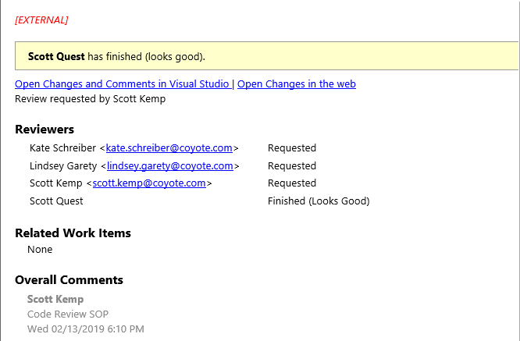

1. Comments can be made and reviewed in two ways
   1. From the Code Review screen select Add Overall Comment.
      1. Make a comment and select Save
      2. Then select Send Comments

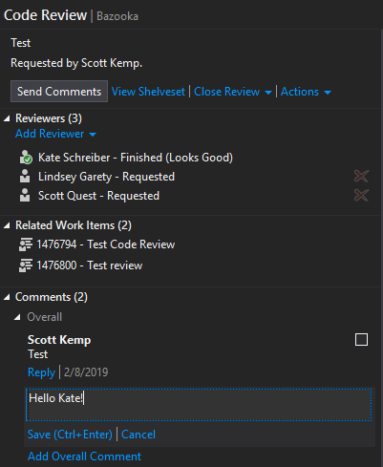

* 1. Make a comment from the Code Review Request
     1. There are several ways the request can be searched/viewed on coyote.visualstudio.com. I find the easiest way to be from the Code Review
     2. From the Code Review select Work Item.
     3. Select the Work Item listed

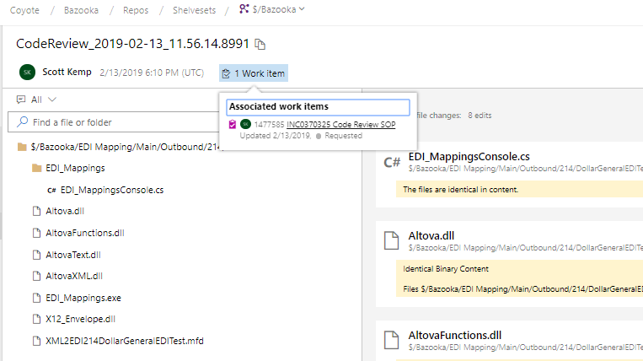

* + 1. You may add a comment and save the Code Review
    2. Emails will send to the requestor as comments are made

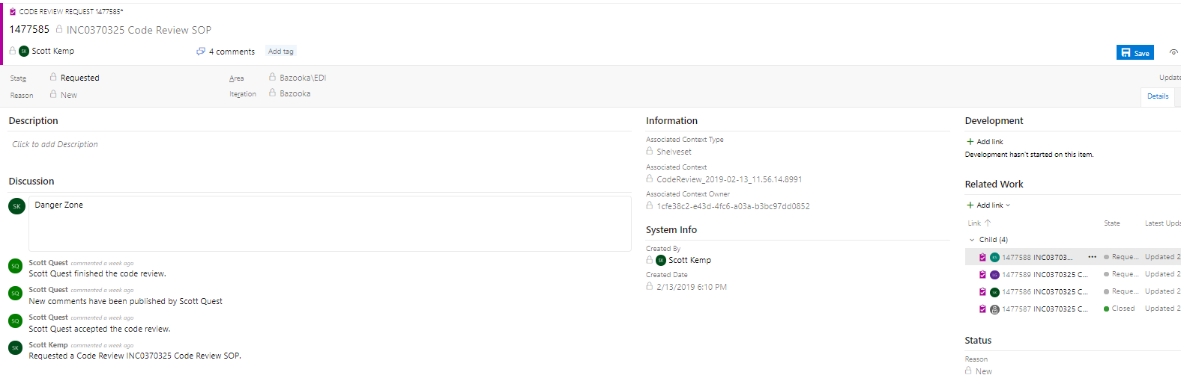

1. To review recently finished or recently closed reviews
   1. Navigate to the My Code Reviews & Requests section and select one of the options from the drop down

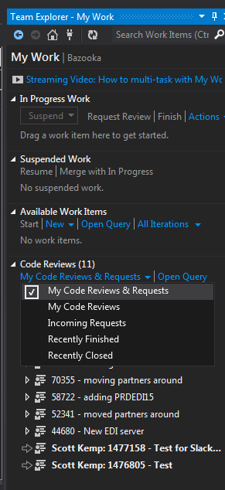

* 1. View the Code Reviews for the option selected

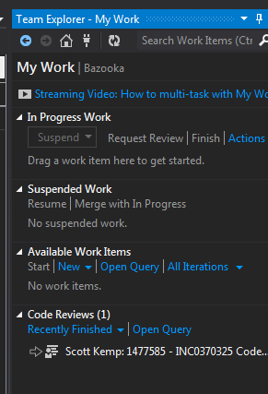

**Closing the Code Review for a Requestor**

1. If your code review is Completed as *With Comments* or *Needs Work*
   1. You will need to close the review and request a new code review after the comments and issues have been addressed.
2. If your code review is Completed as *Looks Good*
   1. You may close the review and deploy your changes to production.
3. To close the Code Review, navigate to the My Code Reviews & Requests section of My Work
   1. Select your code review
   2. From the Close Review Dropdown select Complete
4. If your Code Reviewer has marked the code as *Looks Good*, then you may deploy your changes to production

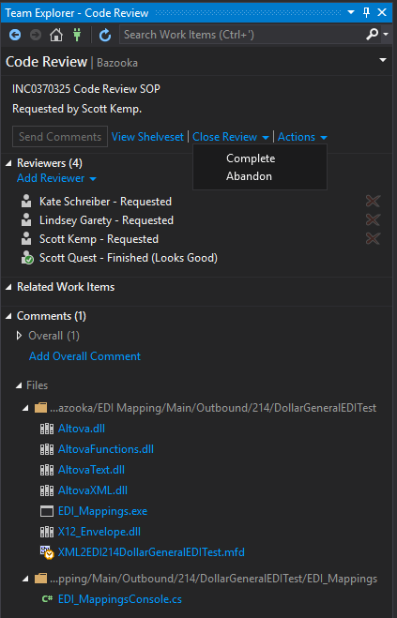

**Deploying to Production:**

1. When Deploying to production, you will need to include the Code Review Number of the Approved Review in your check-in comment. This number can be found in the Code Review email.

